THE 4

DESIGN PRINCIPLES

1

**CHAPTER 3**

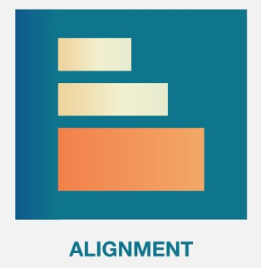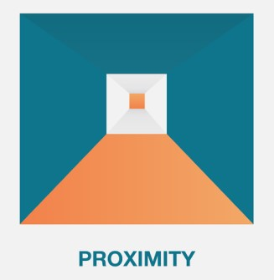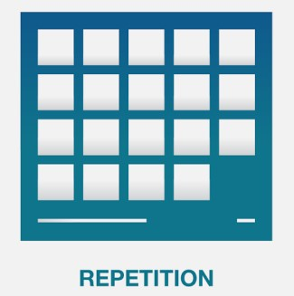

10

MIN

Watch the video to understand

**the 4 design principles**



NOTE : You don’t need to watch the chapter

**TOOLS**

EXPLORE

EXPLORE



15

MIN



# Now you can watch the video again or look on the web

Answer in teams to the following questions

1. Why should we **repeat the style of elements** in our design ?
2. Why should we use **contrast** in design ?
3. What can we use to **increase the contrast** between 2 elements ?
4. What does it mean when 2 elements are **close** ? are **far** away from each other ?
5. Why **whitespace** is important in your design?
6. What are the 4 types of **alignments**?
7. What does alignment bring to your design?

# Basic design principles

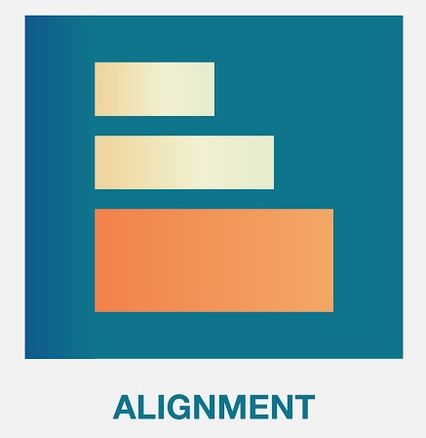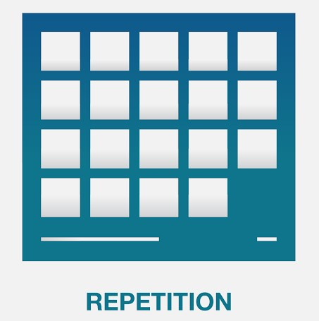

|  |  |  |  |
| --- | --- | --- | --- |
| Things that are related should be **close to each other** | Not related elements are  **graphically different** | **Repeat style** to reinforce the structure  and the unity of your  design | **Align elements** together to reinforce their connection |

## EXPLORE

On which team is HIM ?



05 MIN CLASS

And why ?



RONAN

HIM

JEANNE

RADY

PISETH

NOEMIE

RATHA

TEAM A

TEAM B

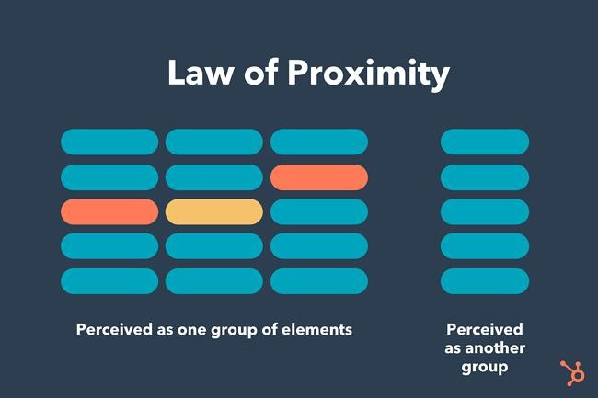

**Proximity**

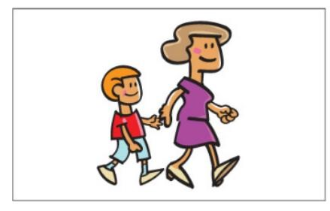Things that are related should be close to each other

*Together*

Things that are NOT related should be far away from each other

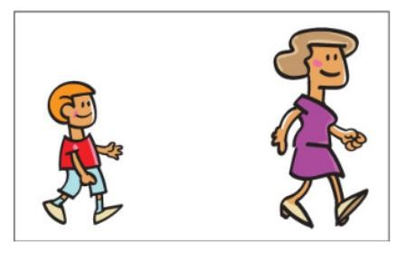

*Not together*

ANALYSE What are the elements close in proximity here ?



05 MIN CLASS



## CORRECTION

What are the elements close in proximity here ?



Those 2 elements are together

ANALYSE

# Activity 2



Team discussion : what are the group of elements here ?

05 MIN CLASS

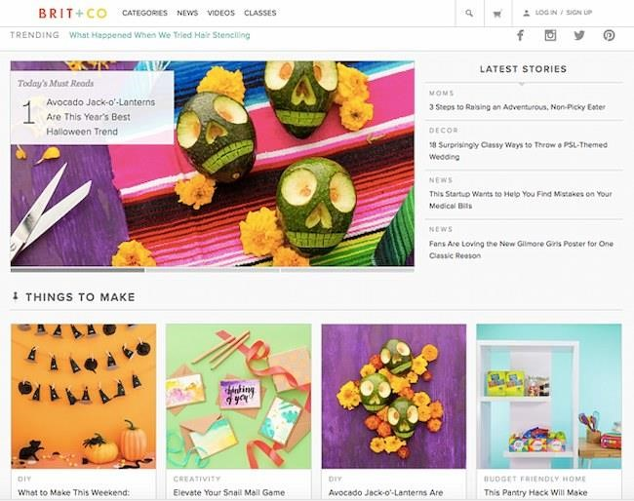

CORRECTION

# Activity 2

Team discussion : what are the group of elements here ?



Some examples

of groups

EXPLAIN

## By **grouping** similar elements

Page is more **organized** You know **where to start** You know **where to stop**

 *Where are the groups on this slide ?*

## Basic design principles



|  |  |  |  |
| --- | --- | --- | --- |
| Things that are related should be **close to each other** | Not **related** elements are  **graphically different** | **Repeat style** to reinforce the structure  and the unity of your  design | **Align elements** together to reinforce their connection |

### EXPLORE



05 MIN

**Same** or **different** ?  **Same** or **different** ?

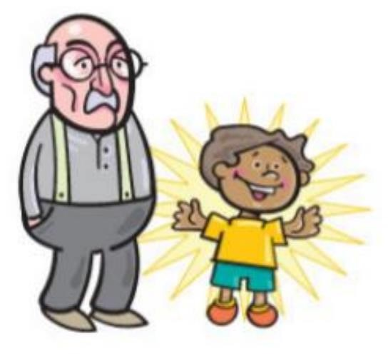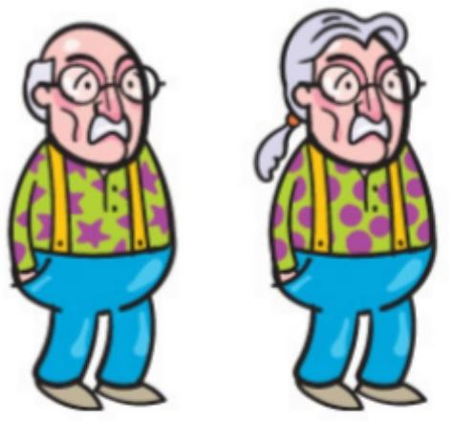

*When things are not the same, make them* ***very*** *different !*

**Same** or **different** ?**Same** or **different** ? unclearClearly different

### EXPLAIN

05 MIN **Contrast can be done in many ways…**



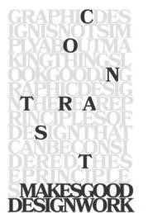Text

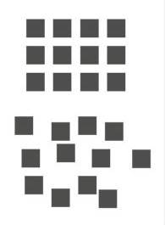

Order

disorder



Size



Shape

Color

Font / size

# Contrast

A visual must contain 1 or many **elements in contrast**, to guide the reader eyes into the page

 *What is contrasted in this slide, and why ?*

## ANALYSE

Analyze **contrast** on below visual:



- Which elements are contrasted, **how** ?

05 MIN CLASS - Which visual is better, why ?

|  |  |  |  |  |  |  |  |
| --- | --- | --- | --- | --- | --- | --- | --- |
| |  | | --- | | FONT | |  | | |  | | --- | | SHAPE | | |  |
| **LIBRARY**  PNC CLUB  **WHY READING IS SO IMPORTANT ?**  Reading and writing work in similar ways. Reading improves your writing style and flow. Writers learn to perfect their craft by taking inspiration from other writers. It’s impossible to be a good writer if you don’t read. Acclaimed author Stephen King is said to carry a book with him wherever he goes. He even reads while eating. | | |  | | LIBRARY  PNC CLUB  WHY READING IS SO IMPORTANT ?  Reading and writing work in similar ways. Reading improves your writing style and flow. Writers learn to perfect their craft by taking inspiration from other writers. It’s impossible to be a good writer if you don’t read. Acclaimed author Stephen King is said to carry a book with him wherever he goes. He even reads while eating. | | |

A B

## CORRECTION

**WHY READING IS**

**SO IMPORTANT ?**

PNC CLUB

Reading

and

writing

work

in

similar

ways

.

Reading

improves

your

writing

style

and

flow

.

Writers

learn

to

perfect

their

craft

by

taking

inspiration

from

other

writers

.

It’s

impossible

to

be

a

good

writer

if

you

don’t

read

.

Acclaimed

author

Stephen

King

is

said

to

carry

a

book

with

him

wherever

he

goes

.

He

even

reads

while

eating

.

**LIBRARY**

Main title strong color

We switch to black background To **increase attention** We increase the question font size + bold

To **catch the reader attention**

## ANALYSE

Analyze **proximity** and **contrast** on below visual:



- Which elements are grouped, **why** ?

05 MIN CLASS - Which elements are contrasted, **how** ?



## ANALYSE

Analyze **proximity** and **contrast** on below visual:



- Which elements are grouped, **why** ?

05 MIN CLASS - Which elements are contrasted, **how** ?

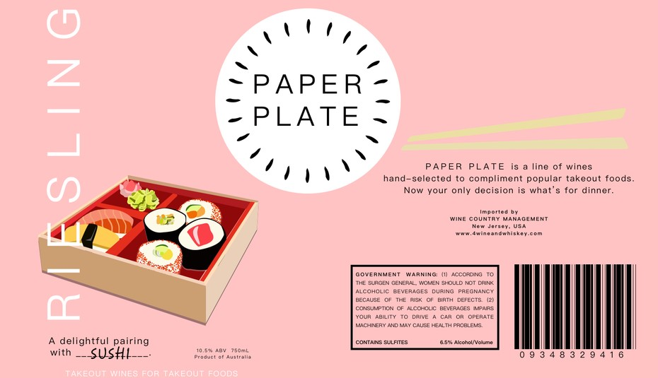

## Basic design principles



|  |  |  |  |
| --- | --- | --- | --- |
| Things that are related should be **close to each other** | Not related elements are  **graphically different** | **Align elements** together to reinforce their connection | **Repeat style** to reinforce the structure  and the unity of your  design |

In which kitchen are you the **most comfortable** ?

A B

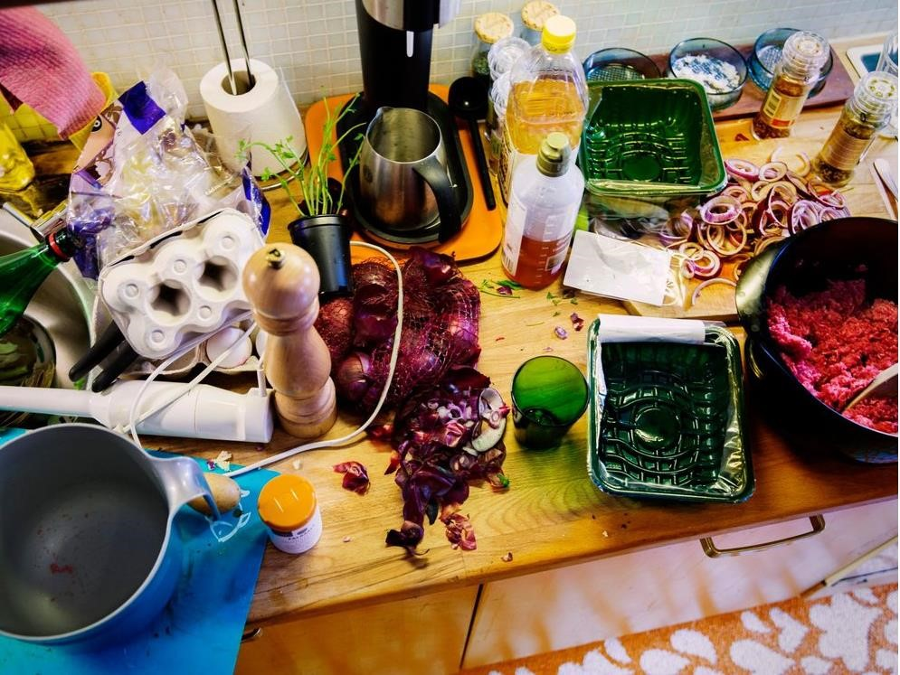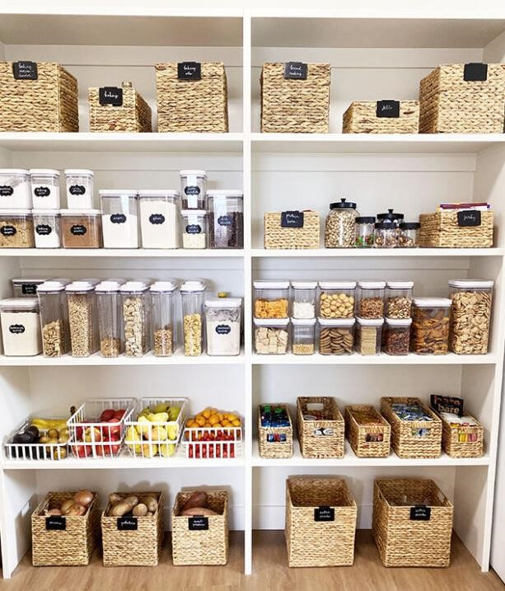

## **Alignment**

Nothing should be placed on the page **arbitrarily**



*4 options only !*

### EXPLAIN

An **invisible line** connect aligned elements

✓

Be like teacher Him

✓

Be designer

**MY GOALS IN LIFE**

Because I’m creative and I like

Photoshop

He is a role model for me, so

skilled and so handsome

Even if elements

are far away,

**The alignment**

**makes them**

**strongly unified**



05 MIN

A center alignment is A right/left alignment gives a

**Safe, easy to use, comfortable, formal more sophisticated** impression

Phnom Penh, Cambodia

**WEP TEAM**

+855

–

89

-

456

-

8

PNC street 78

*The best of the best*

Phnom Penh, Cambodia

**WEP TEAM**

+855

–

89

-

456

-

8

PNC street 78

*The best of the best*

Those 2 element

are linked

Together

With the

alignment

Left

Which alignment to choose to put text on rectangles ?Right



Center

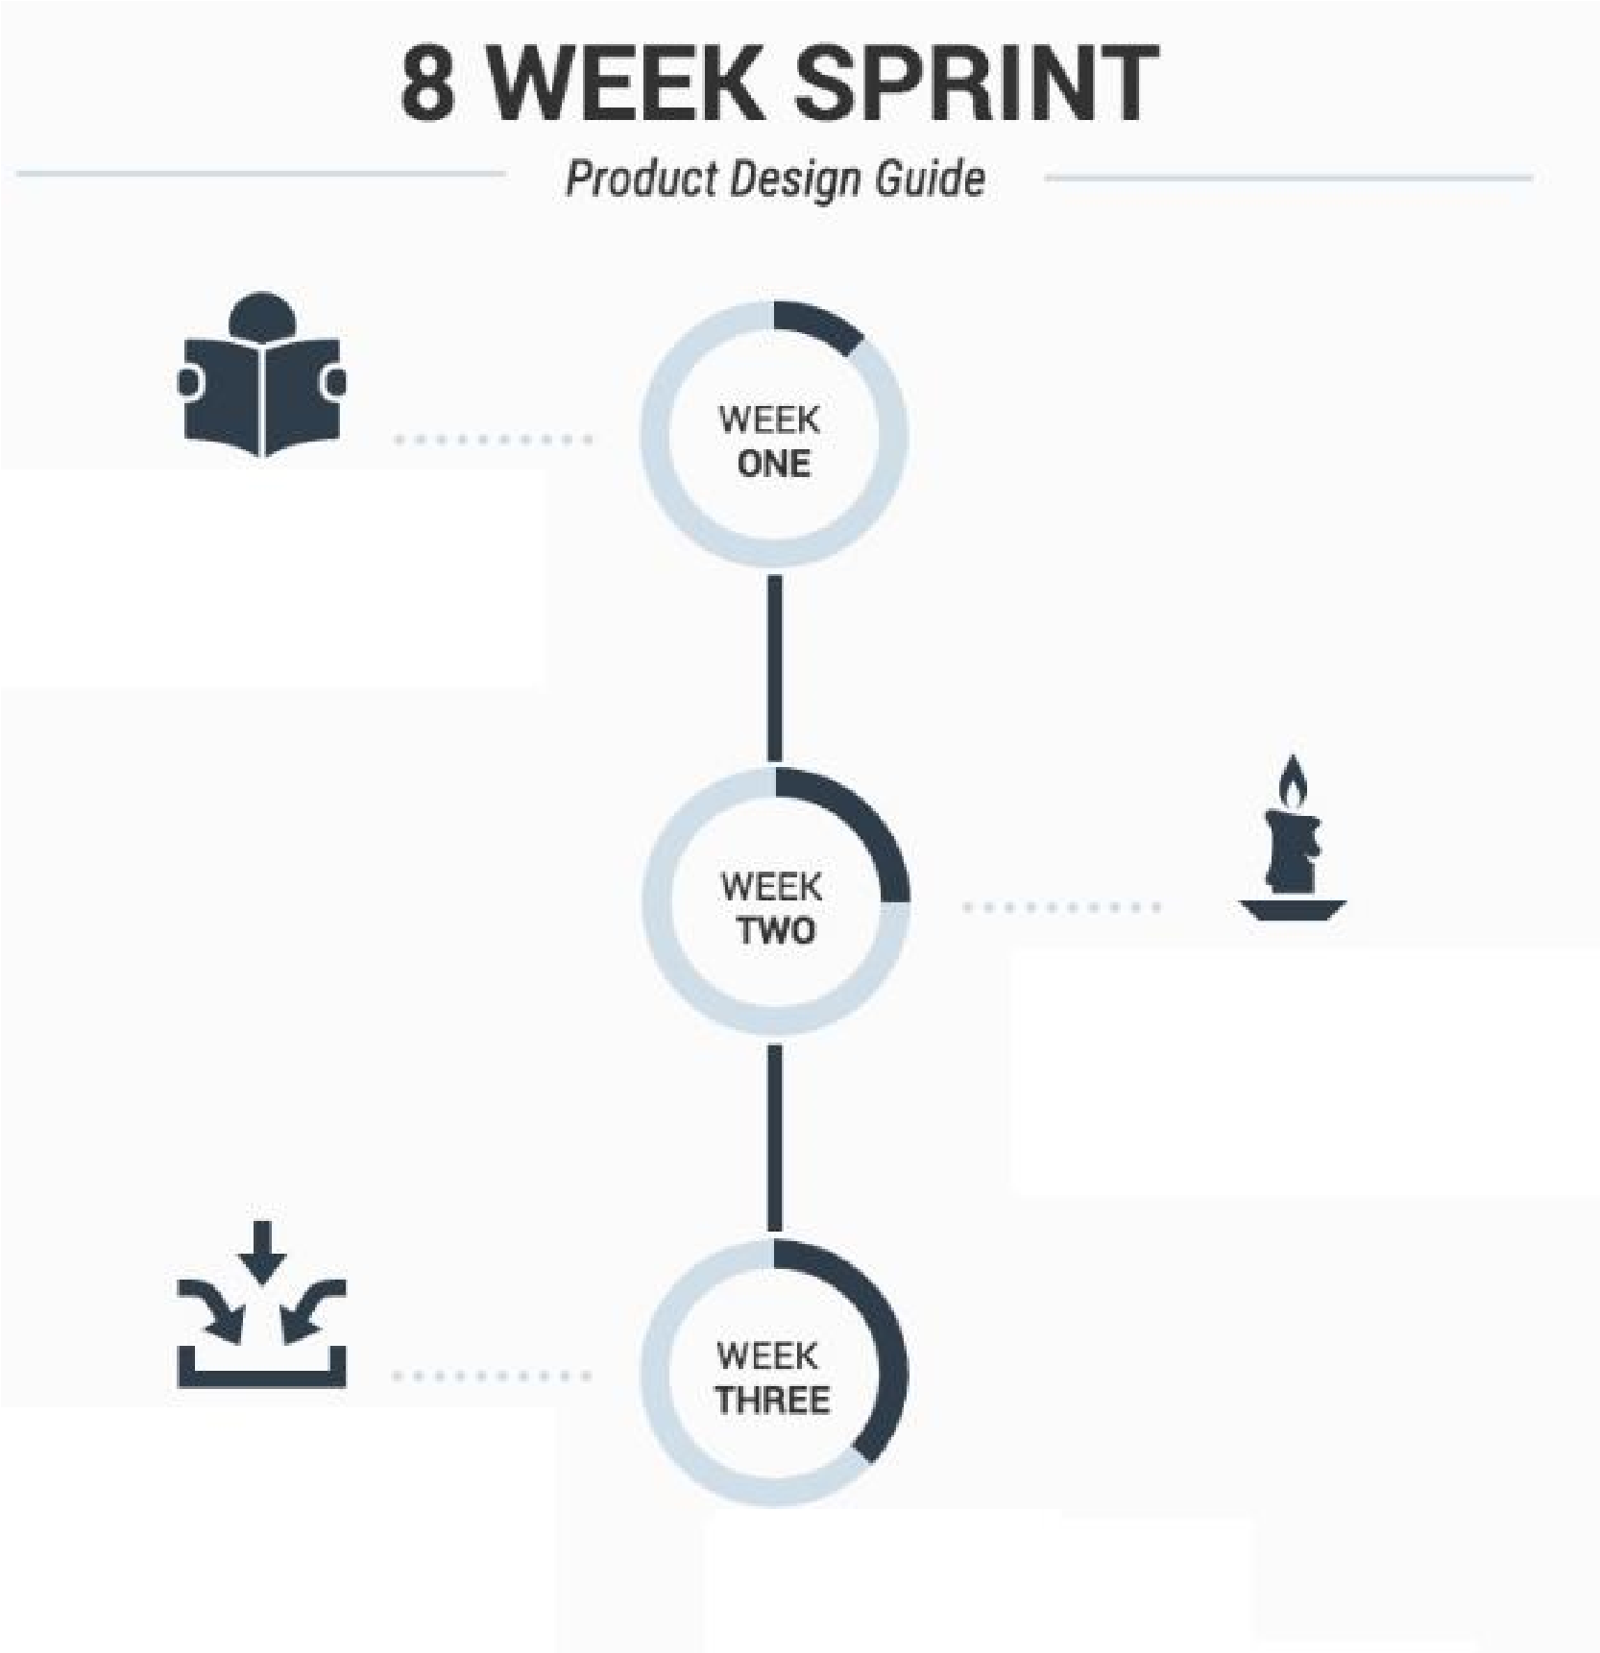

05 MIN CLASS Justified

CENTERED



Similar to other design

principles like balance

and proportion

Similar to other design

principles like balance

and proportion

Similar to other design

principles like balance

and proportion

|  |  |  |
| --- | --- | --- |
| **PNC HOSPITAL**  **We welcome new patients !** | |  |
| Family Medicine | Women Medicine | Specialty Services |
| Adult and Family practice Internal Medicine  Infusion Gynecology medicine  Sexual heath  Travel Medicine | | HIV  Research  Pharmac0  Cancers  Head  Nose |
| +805 78 456 141  +805 78 456 11 | | +805 78 456 114 |

Fix the alignment of the visual elements



05 MIN CLASS

Fix the alignment of the visual elements

Family Medicine

Women Medicine

Adult and Family practice

Infusion

Sexual heath

Travel Medicine

Internal Medicine

Gynecology medicine

HIV

Research

Pharmac0

Cancers

Head

Nose

+805 78 456 11

+805 78 456 141

+805 78 456 114

***We welcome new patients !***

**PNC HOSPITAL**

Specialty Services

We reinforced each category

with

**a left alignment**

:

•

Department items

•

Department title

•

Department phone

Left

Which alignment to choose to put text on rectangles ?Right



Center

Justified

5 MIN CLASS

|  |  |  |  |  |  |  |  |  |
| --- | --- | --- | --- | --- | --- | --- | --- | --- |
|  |  |  |  |  |  | |  |  |
|  | The cat is a domestic species of small carnivorous mammal. It is the only domesticated species in the family Felida and is often referred to as the domestic cat to distinguish it from the wild members of the family A cat can either be a house cat, a farm cat or a feral cat the latter ranges freely and avoids human contact. | .  ; |  | The cat is a domestic species of small carnivorous mammal. It is the only domesticated species in the family Felida and is often referred to as the domestic cat to distinguish it from the wild members of the family. A cat can either be a house cat, a farm cat or a feral cat; the latter ranges freely and avoids human contact. |  |  | The cat is a domestic specie of small carnivorou mammal. It is the onl domesticated species in th family Felida and is often referred to as the domesti cat to distinguish it from th wild members of the family A cat can either be a hous cat, a farm cat or a feral cat the latter ranges freely and avoids human contact. | s s y e  c e  . e  ; |
|  |  |  | | | | | | |

JUSTIFIED

### Basic design principles



|  |  |  |  |
| --- | --- | --- | --- |
| Things that are related should be **close to each other** | Not related elements are  **graphically different** | **Align elements** together to reinforce their connection | **Repeat style** to reinforce the structure  and the unity of your  design |

#### EXPLORE



05 MIN CLASS Who are on the **same team** ?



#### EXPLORE

Who are on the **same team** ?

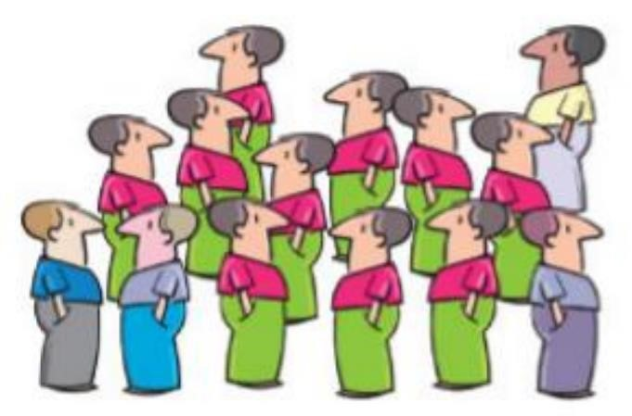

Repetition of

their clothes

makes it clear

they belong to

the same team

#### EXPLAIN



### 05 MIN **Repetition**

Repeat the style of some elements to **unify** and **link** them together

*What is repeated in this slide, and why ?*

With key words

Repeat the style of some elements to

**unify**

and

**link**

them together

**Repetition**

EXPLAIN



05

MIN



Color is repeated to connect the definition

logos are repeated in all slides

So that teacher knows what to do

*What is repeated in this slide, and why ?*

ANALYSE What is repeated here ?



05 MIN CLASS

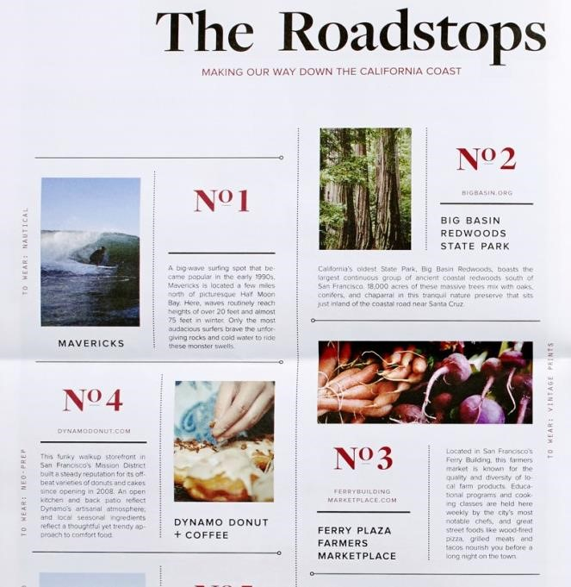

#### CORRECTION



Title color , size,

**font**

**Grid**

system

Separator style

**spacing**

**aligment**

ANALYSE What is repeated here ?



05

MIN



CLASS

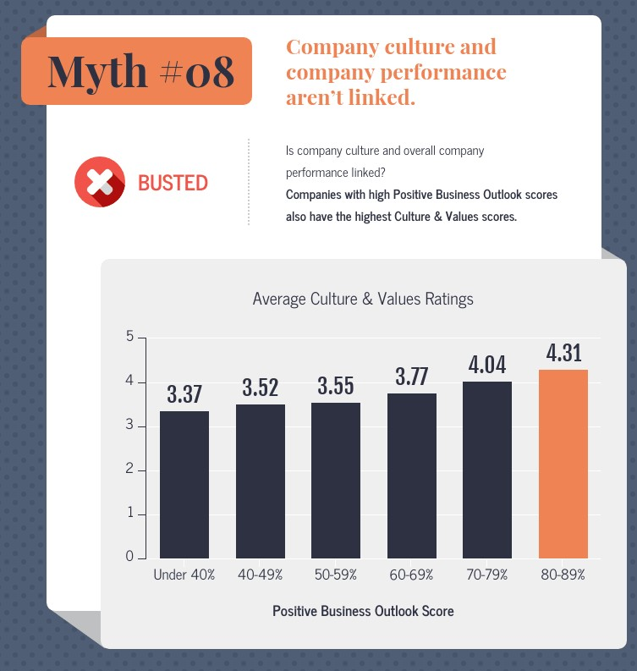

HOMEWORK

#### INDIV **For next time**



✓ Read and understand the **slides** and the **handout** ✓ For each principle, **design a good and a bad** example

 PROXIMITY REPETITION CONTRAST ALIGMENT

**BAD**



**GOOD**



**BAD**



**GOOD**



**BAD**



**GOOD**



**GOODBAD**